# Oracle an PHP connection

1. **Step 1: Download Guides**

* Some of the applications may not be available on internet, for better solution Our team has decide to give drive link where Oracle 11g , Apex 19.3 version and PHP 8.3.2 is available.
* Link:<https://drive.google.com/file/d/1klPDop9bJhCJ8jA5D8JheZvscRtlCcj4/view?usp=sharing>

1. **Step 2: Oracle 11g Setup Guide**

* After download extract the file and go to file there you can see **setup.exe** click on it

* After this you can see like this in the picture below

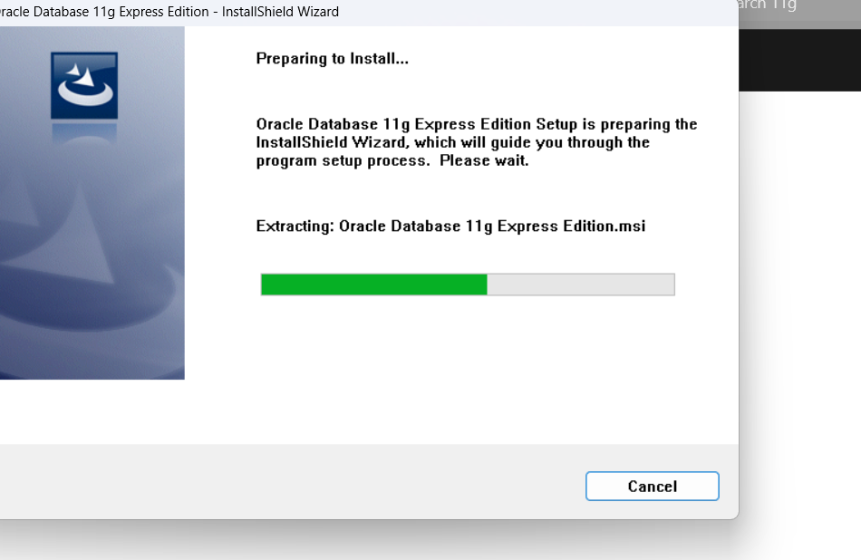

* Accept the terms in the license agreement.

* Make sure your destination folder or directory.

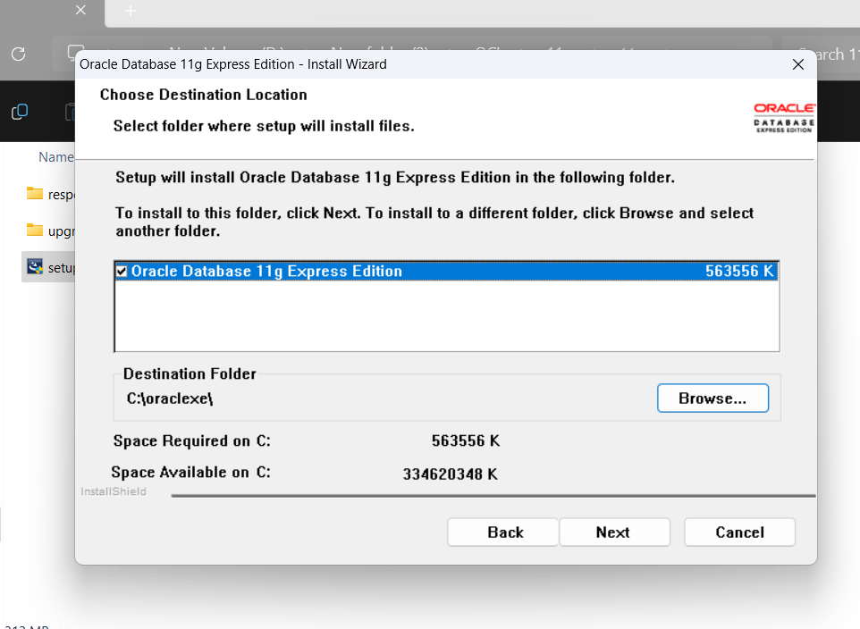

* Insert password for mysql (make sure your both password is same)
* After this you can see the setup status.

* Now click on finish and your setup is complete

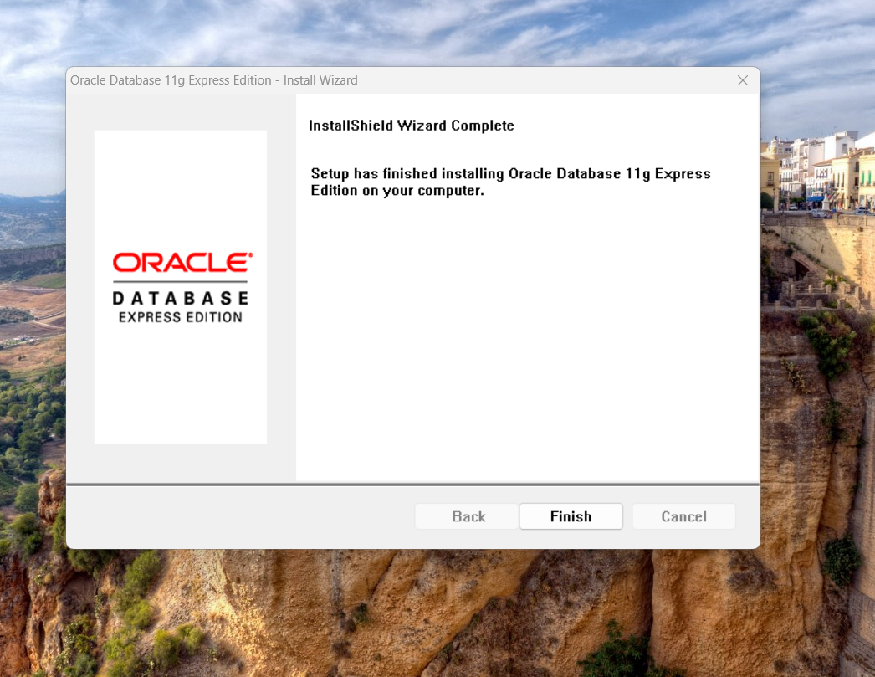

1. Step 3: Setup oracle apex 19.2

* Unzip the downloaded file
* Copy your unzipped apex file to drive C:
* Start command prompt as administrator
* Change your path to apex file which is in C: drive

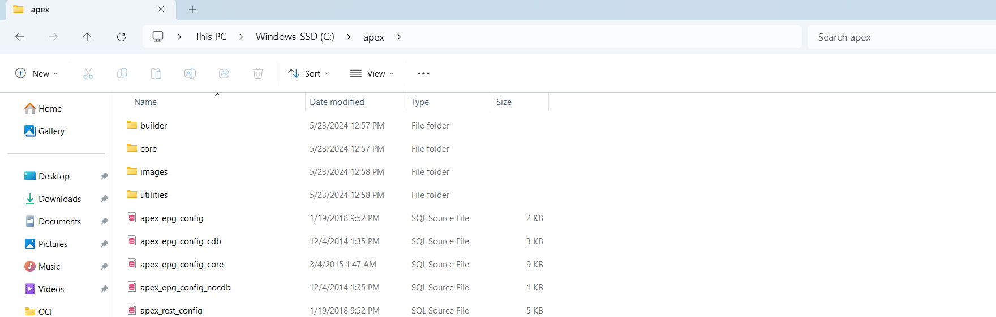

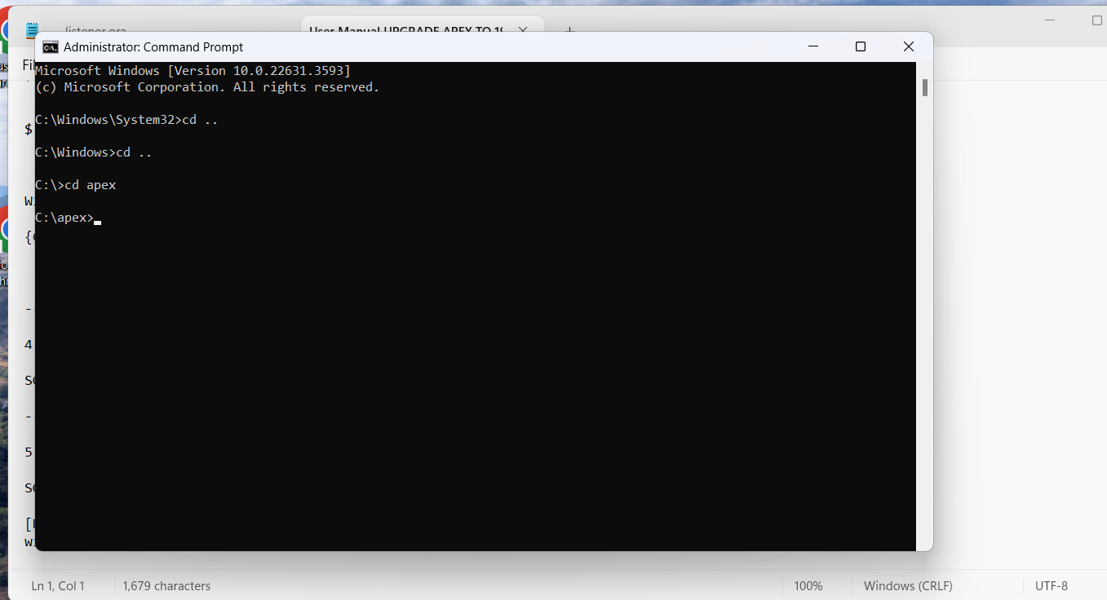

* Type sqlplus
* Username and password (password you set in oracle 11g upgrade)

* Connect to Sysdba

* Install application express:SQL>

@apexins SYSAUX TEMP /I/

* Login back to sqlplus from same directory

* SQL> @apex_epg_config.sql C:apex/

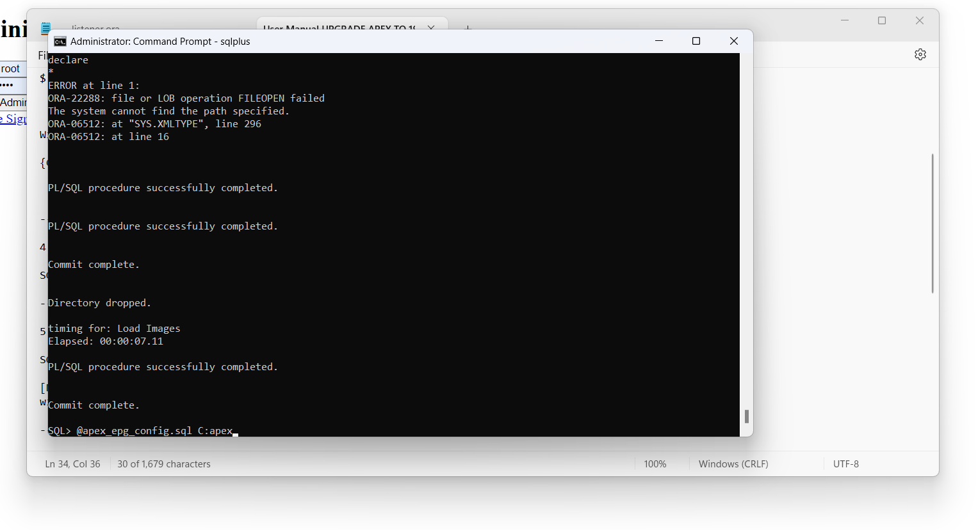

* Change application password SQL> @apxchpwd

* password must be greater than 8 contains number and symbols except @

1. Setup oracle administration

* <http://localhost:8080/apex/apex_admin> (run this link in website enter user name and password as set it in a installation process of apex 19.2)

* Click on create workshop

* Enter workspace name

* Give Schema Name and Password

* Fill up form properly

* Click on Create Workspace

* Workspace Created

* Sign out the page

* Sign in the page

* Change password

* Finally Completed

